CSC2002S Myrin Naidoo

Assignment 4

Technical Overview

I used a single main class for each variant of cache. It would have been more efficient to make two classes that took in the size of the block and bytes/block (one for single level and one for double). The code wasn't extensive so I found it viable to code each separately. During debugging I found I should have trusted my initial instinct and coded the separate classes as the same errors needed to be repaired over multiple sets of code. In order to get the address of the block I divided the value in the .addr file by the bytes/blocks and then got the modulus of the result with the number of blocks. I made 2 main classes, one for L1 and one for L2) that take in the block size and number of bytes per block. This was used to test the different block sizes and bytes/block.

Results and Analysis

The simulator showed a clear increase in the number of hit is we increase the byes/block size. This was tested by using a set number of blocks and increase the bytes per block. Ass seen in the pictures below, I did this for a single level cache and a two level cache. Next I fixed a bytes per block value and changed the number of blocks. This allow showed an increase in hits as the number of block increase. This shows that a larger cache with more bytes per block would increase the speed of a computer. In practice cache memory can't just be increased as it is expensive.

|  |  |  |  |
| --- | --- | --- | --- |
|  | Blocks | Bytes/Block | Cycles |
| L1 | 16 | 16 | 154446260 |
| L1 | 16 | 32 | 97243070 |
| L2 | 16 | 16 | 45066560 |
| L2 | 8 | 32 | 45062330 |

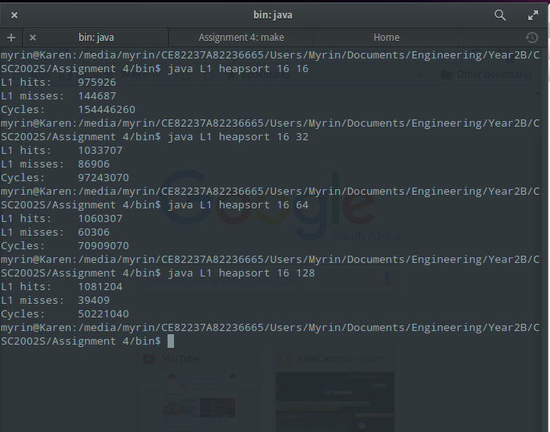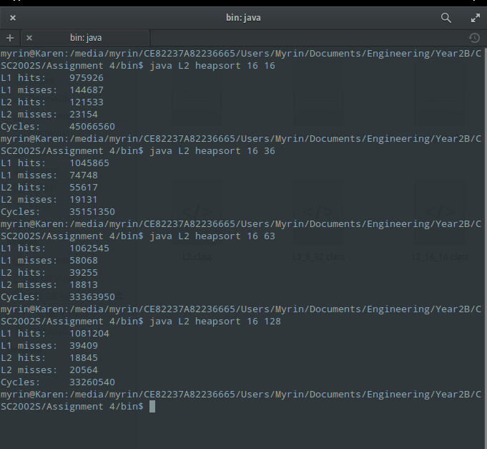

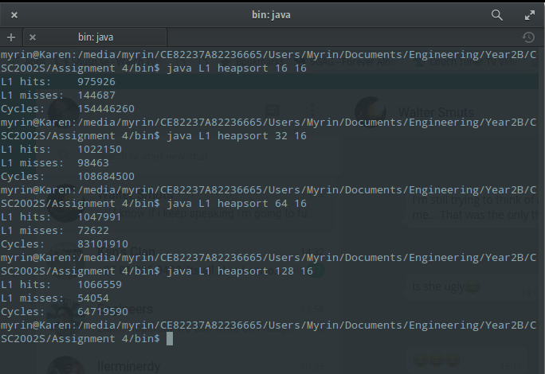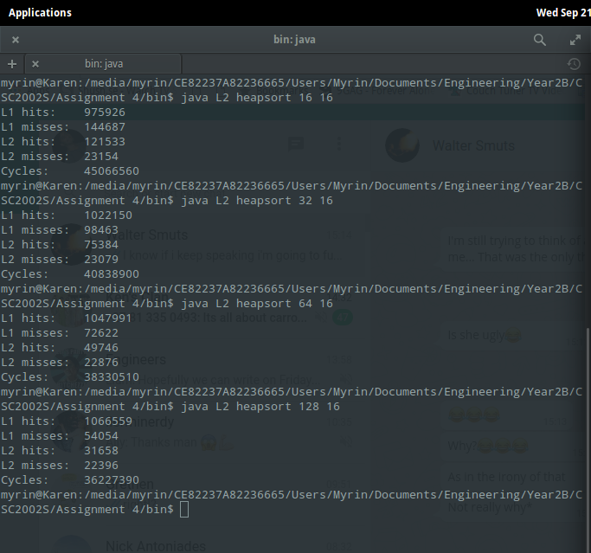

Evaluation

The configuration that performed the best, of the ones that were required, was the two leveled cache with 8 blocks and 32 bytes per block. L1 cache is more expensive and faster. L2 cache is cheaper but slower. Increasing L2 cache does speed up the processing but not as much as an increase in L1 cache would. For a fixed size L1 cache I would increase the bytes per block. In the

Future Work